APSC 496

Critical Function Prototype Report

Praxim - Surgical Robot

Submitted on: 30-NOV-2009

Submitted by: Nicholas Adams

Davy Chiu

Ibrahim Gadala

David Mountford

Erica Wodzak

Table of Contents

1.0 Introduction 1

2.0 Critical Function 1

3.0 Description of Prototype 2

Prototype 1 3

Prototype 2 4

4.0 Experimental Method 5

5.0 Analysis of Results 7

6.0 Future Steps and Updated Timeline 11

7.0 Conclusion 11

Appendix A - Supplementary Simulations 13

Prototype 3: 13

Prototype 4: 15

Appendix B - Linear hard constraint power screw/worm gear calculations 18

Appendix C - MATLAB Code and Results for PT1 21

Appendix E - MATLAB Code and Results for PT3a 30

Appendix F - MATLAB Code and Results for PT13b 33

Appendix G - MATLAB Code and Results for PT4 36

# 1.0 Introduction

Once the critical function of “Permits User to Perform 3-Dimensional Motion” was determined, steps were taken to test two prototypes that were being considered. These tests consisted of a basic experiment that tested each prototype's range of motion, and a MATLAB simulation that also investigated the range of motion of each prototype.

# 2.0 Critical Function

The critical function evaluated is this document is the “cutting tool moves” function, identified in the functional decomposition. The user’s ability to move the cutting tool in 3D space is essential to the ultimate project goal of generating a 3D hard surface. Furthermore, this function interfaces with other functions that have significant impact on the design, including the mechanism used to implement/move the hard surface, the means by which the device is secured to the knee, and the different shapes that can be created/cut using the device.

This function also has a direct impact on many of the other design specifications:

* The chosen mechanism will directly and most heavily affect the size and weight of the device
* The motor, which will adjust/control the hard constraint component, will have a speed and accuracy dependency on the design of the device’s arm
* The method of user interaction with the device will also be affected by the arm design

As a result, it is important that the above listed specifications are considered early in the interfacing conceptualization process so as to fully consider its affects on the overall design criteria and goals.

From the analysis performed in the following report, the mechanism that permits the cutting tool’s motion in 3-dimensional space will be finalized, and various link lengths will be assessed regarding their impact on the overall design.

# 3.0 Description of Prototype

The prototype that is developed to assess the 3D motion function is based on a previous prototype used to evaluate the feasibility of the concept in 2009. The current prototype implements a three-link mechanism consisting of two rotational joints and one linear joint. The major disadvantage of this concept is the size and weight of the linear joint, and thus linear joints will be eliminated from all further prototypical designs so as to follow the objective of reducing size/weight.

The portion of the existing prototype used for the critical function prototype (CFP) is shown in . The motor and encoders were removed from Linkage 1 and Linkage 2, leaving only the mechanism with two degrees of freedom. The ideal lengths of Linkage 1 and Linkage 2 are 5 cm and 4.5 cm respectively, based on Hungr’s analysis (insert reference). The critical function prototype developed (by who? This needs to be specified) however **by…** uses link lengths of 5.5 cm and 6.0 cm. (should explain why we’re not using Nikolai’s numbers and ours instead) This combination of link lengths will be used to evaluate the potential operating enveloped of the device, however further analysis is necessary before these lengths are finalized.

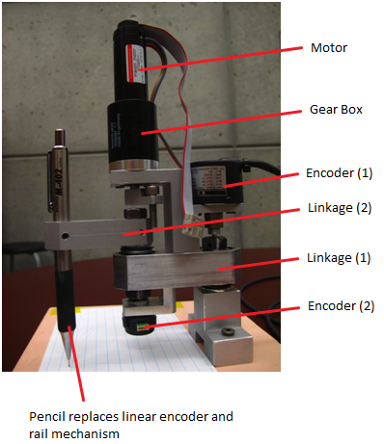

Figure – Dynamic Physical Constraint mechanism used in existing prototype

## Prototype 1

Prototype 1 (PT1) consists of three rotational joints at positions 1, 2 and 4. Bearings have been used at joints 1 and 2 while Link 4 is allowed to rotate by a setscrew held in place by a setscrew. Link 3 is a kept stationary by a setscrew and is not allowed to rotate. Link 3 has been designed to be repositioned depending on the experimental requirements. Link 4 has also been designed to vary in length from 3 cm to 6 cm in increments of 1 cm, but will be set at 6 cm for prototype two. Figure 2 provides an overview of the PT1 mechanism; the figure highlights the relationship between Link 3 and Link 2, and the position of Link 4 and the cutting tool, because they cannot rotate with respect to each other.

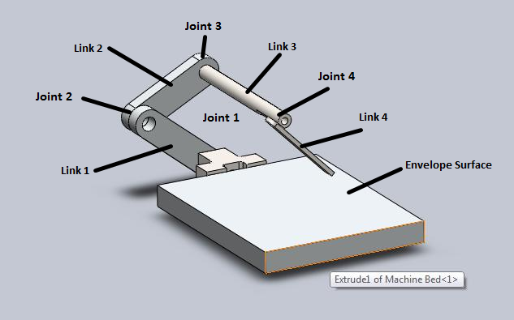

Figure – Model of prototype 1

Table – Prototype 1 link lengths

|  |  |
| --- | --- |
| **Link** | **Length [cm]** |
| Link 1 | 5.5 |
| Link 2 | 6.0 |
| Link 3 | Set to 10 |
| Link 4 | 6.0 |

## Prototype 2

Prototype 2 (PT2) consists of four rotational joints at positions 1, 2, 3 and 4. Bearings have been used at joints 1 and 2 while Link 4 is allowed to rotate by a setscrew held in place by a setscrew. Link 3 is allowed to rotate by loosening the setscrew, but a stopper is placed at the end to stop translation. Link 4 will be set at 6 cm for Prototype 2. In model of PT2 – shown in Figure 3 – Link 3 can rotate with respect to Link 2, and thus Link 4 will always be oriented towards the envelope surface as a result.

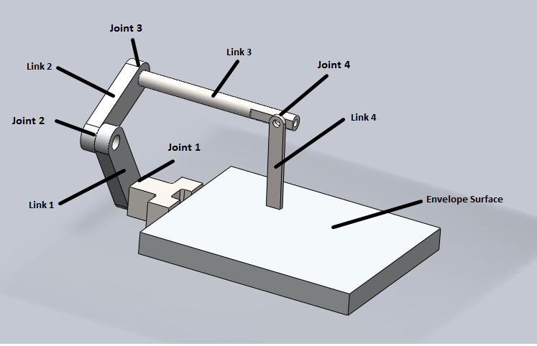

Figure – Model of Prototype 2

Table – Prototype 2 link lengths

|  |  |
| --- | --- |
| **Link** | **Length [cm]** |
| Link 1 | 5.5 |
| Link 2 | 6.0 |
| Link 3 | Set to 10 |
| Link 4 | 6.0 |

# 4.0 Experimental Method

The following experiment was formulated to examine two aspects of both prototypes being considered: the size of the machining envelope to determine if it would have the sufficient workspace to make cuts in a knee replacement surgery, and whether there exist any locations that the tool cannot reach.

**Testing Protocol**

The purpose of the testing protocol is to see if the desired range of motion is achieved with the rotation-rotation-rotation joint configuration design within the requirements specified in the evaluation criteria located in a prior document. In order to complete a uni-compartmental knee replacement surgery, the tool must have access to both femoral lobes.



Figure - Femoral Lobes

This can be achieved in two ways; (1) a linkage mechanism with a range of approximately 16 cm - equivalent to the entire knee - or (2) a linkage mechanism in which Linkage 3 is adjustable, which allows operation on individual lobes using the same mounting position.

**Range of Workable Area**

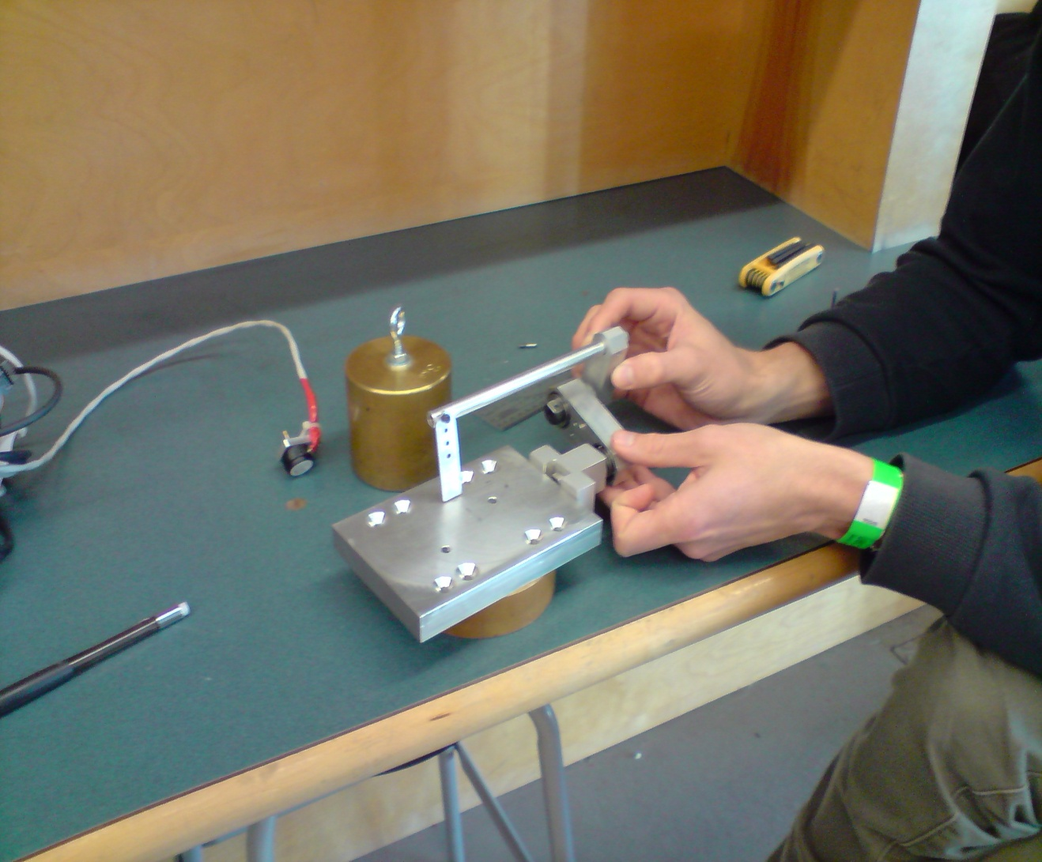This test is to determine the feasibility of two design types: (PT1) four link mechanism with rotational joints at positions 1, 2 and 4 and (PT2) four link mechanism with rotational joints and positions 1, 2, 3 and 4. Steps will be taken to assess the effectiveness of both designs with respect to the entire knee from one position design and the individual lobes design discussed above.

Assumptions/Requirements:

1. Device is rigidly fixed to femur (no play in the bone mount)
2. Link 2 will never be perpendicular to the generated surface
3. Link 4 has a maximum angle of 45 degrees from the vertical position
4. Link 4 cannot come into contact with the support structure
5. Entire knee envelope has a radius of 8cm
6. Single lobe envelope must be 16cm by 8cm
7. Lateral deflection cannot occur
8. Linkages cannot transfer between right and left orientation
9. Link 4 length is 6cm

Method:

1. Setup up mechanism as PT1
2. Position mechanism in right orientation
3. Set reference point to the position where link 4 is perpendicular to surface and in line with the axis of the mechanism
4. Position tool (end of link 4) along the surface of the support structure at a edge of the envelope – on the verge of lateral deflection
5. Moving the tool along the surface and maintaining near lateral deflection position, map out the envelope of the current setup moving link 4 from +45 degree to -45 degree position
6. Maintain -45 degree position keeping tool on the surface, map out the envelope generated until link 1 is perpendicular to the surface
7. Moving the tool along the surface and maintaining link 1 perpendicular to surface position, map out the envelope of the current setup moving link 4 from -45 degree to +45 degree position
8. Maintain +45 degree position keeping tool on the surface, map out the envelope generated until mechanism reaches the lateral deflection position
9. Repeat for all steps for PT2

**MATLAB Simulation**

In order to have a better visual representation of the workable area, a Matlab script was written to plot the possible motion of both concepts. The script generates points at various combinations of link angles at each of the joints and maps these points out to create an envelope volume. The script, however, does not take lateral deflection into account, and thus no final conclusions can be drawn from the generated envelope. Later in the design process, the script will be adapted to optimize link lengths and find the optimal range of angular deflection for each link.

# 5.0 Analysis of Results

After completing a physical prototype of the robot’s new linkage system, the critical function was preliminarily examined with a series of basic tests. The main feature that was tested for is the range of workable area that the linkage permits.

Prototype 1:

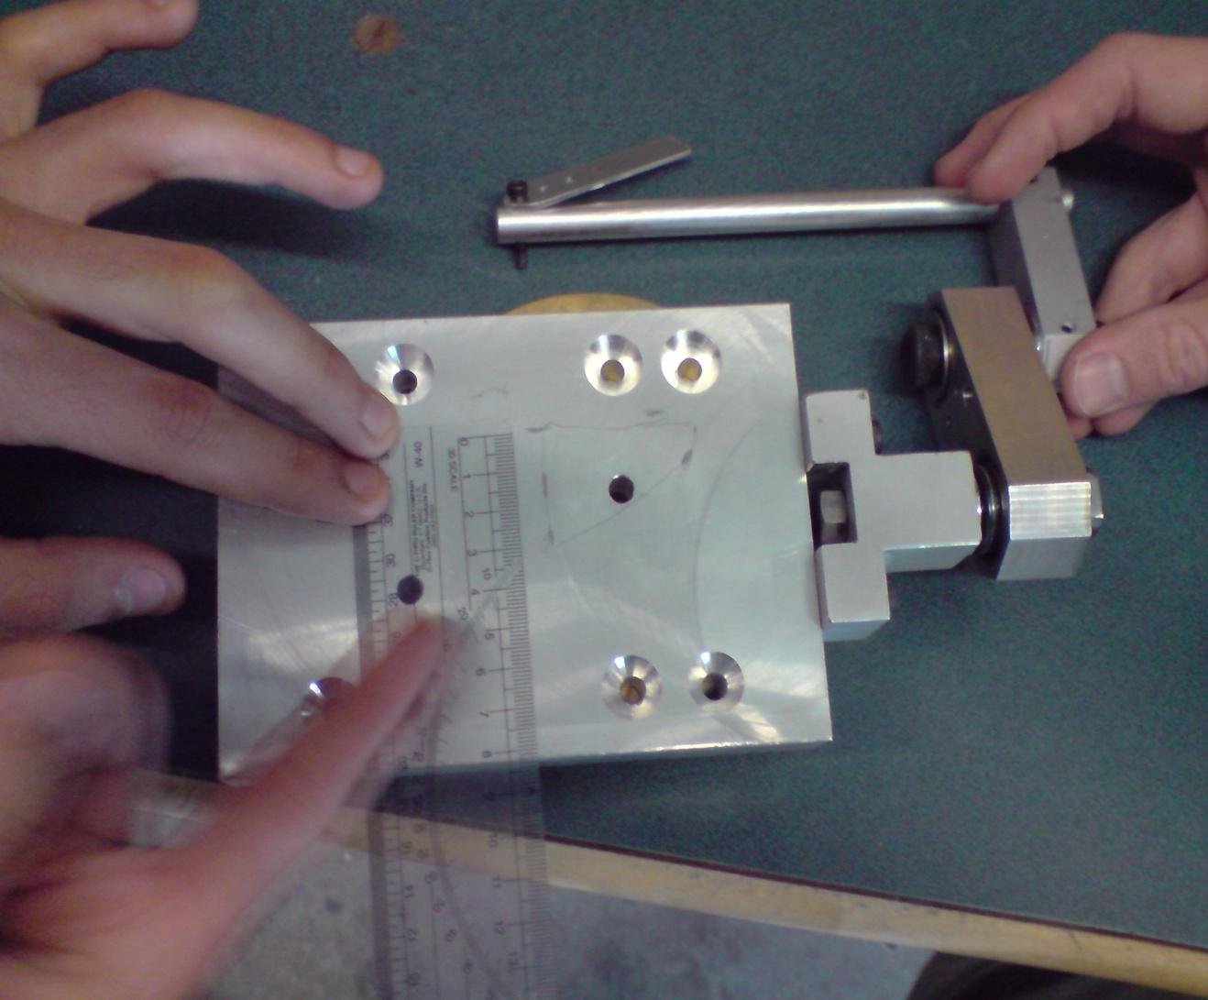At first, the shaft link (3rd link from the bone mount) simply acted as an offset for the system, as it was rigidly fixed against movement with a setscrew in its joint with the second link; the other three links were permitted to rotate in their respective planes. Although this setup provides easier calculations and control predictions of the hard-constraint (due to the fact that 1 less encoder and a less intensive mathematical calculation is necessary), the workable range provided is greatly lacking. Effectively, with the link sizes of the prototype we tested (15 cm shaft and 6 cm tool link), the area was a triangle with a height of only 2 cm and a base length of about 3 cm. {reference to picture with the triangles}. Errors in this analysis include:

* Possible slippage in the setscrew fixation
* Flexibility in the link structure (final prototype will be designed more for sturdiness and rigidity)
* Inconsideration of the tool bit orientation and size.

For the latter of the three errors, it was assumed that the point of contact of the 4th and final link with the surface will provide sufficient tool penetration for cutting, and that the tool will be oriented at an angle to allow for better machining conditions. Thus, it could be stated that the resulting limitation of this analysis is that not all points that the final link that contacted the work surface will result in bone cutting conditions.

Prototype 2:

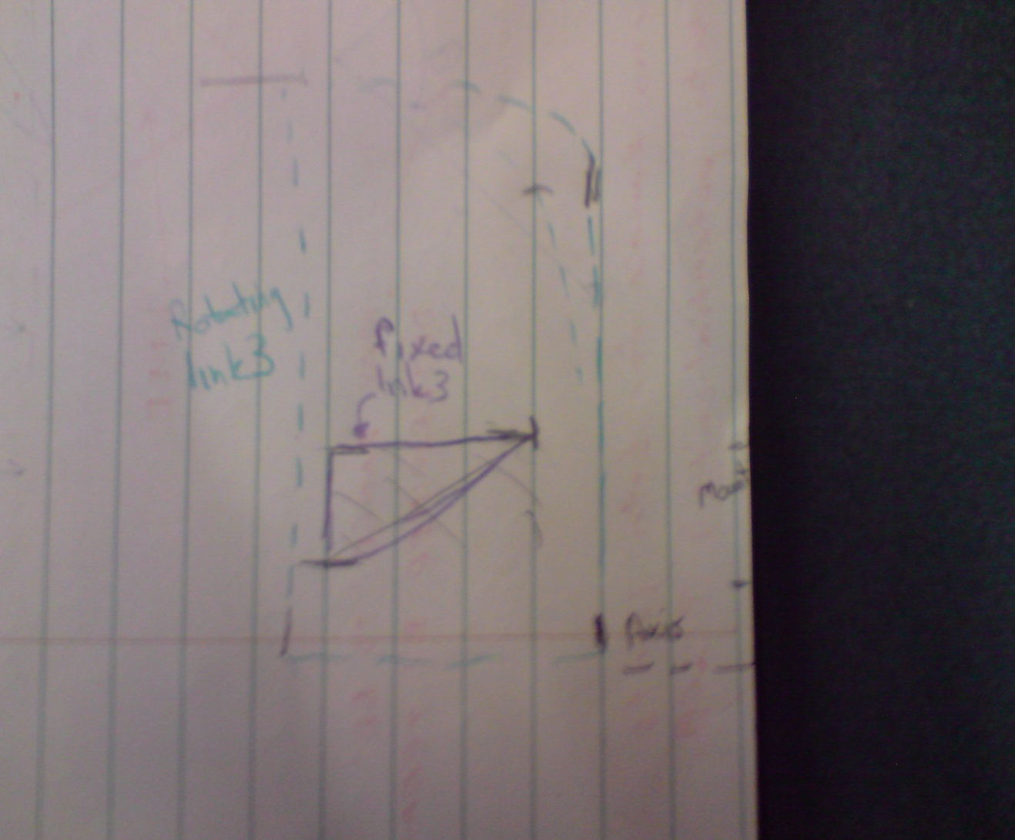It was decided that a test of whether the range from PT1’s setup would be improved if the 3rd shaft link was permitted to rotate about its axis. The change was immediate and obvious; the rotation of the shaft link effectively allowed the projection of its rotation angle to be added to the range of the workable area, thus greatly increasing the workable range. With the same link sizes used for the first testing set-up, this added degree of freedom (DOF) to the third link expanded the workable area to a rectangle with side lengths of 9 cm and 5 cm {reference to picture with the triangles}. However, implementing this extra DOF will require an additional encoder and a more intensive mathematical and computing process for hard surface control. Inherently, this analysis has less possible errors than the analysis of PT1, since slippage of the shaft link is permitted, and the tool can be oriented at a greater range of angles than when the shaft is secured in place.

There are still, however, errors in this analysis arising from linkage system flexibility, and possible slippage of the shaft link *axially*, which would not occur in a real-life scenario. Thus, the main assumption for the analysis of PT2 is that while taking work area measurements, the shaft did not slip axially, and therefore provided accurate results yielding a larger final work area. This means that a major limitation of this analysis is that the work area measured is the upper value of the range possible, since the shaft could not have possibly stayed fixed at the joint, yet we assume it did so we make a obtain a less conservative result. In essence, the undisputed result of this analysis is that prototype 2 has a significantly larger work area than prototype 1.

Figure - Range of Motion for PT1

Figure - Range of Motion for PT1 and PT2

**MATLAB Simulation Results**

The MATLAB simulation has been used to verify the results generated from PT1 and PT2, and to provide an estimate of each prototype’s work-area envelope.

Prototype 1:

Figure 7shows the enveloped generated for PT1 using the link lengths from Table 1. In the MATLAB script, Link 4 has been offset by 30 degrees, resulting in the orientation shown in Figure 7. In the x-y plane, horizontal to the envelope surface, PT1 has a range of approximately 10 cm by 15 cm. These results are somewhat deceiving, however, as there are many locations within this volume that cannot be reached by the cutting tool. What’s more, the tool is constrained to specific paths when trying to move in a single plane; this restricted motion can be seen by the significant holes in the generated operation space. Figure 7 also suggests that the vertical envelope is reduced to the point that the user will not have freedom of motion away from the surface in some areas.

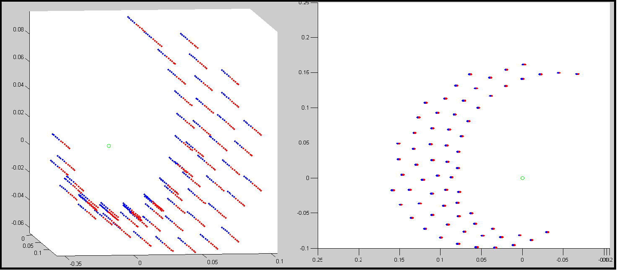

Figure – Prototype 1 MATLAB range of motion simulation

Prototype 2:

The analysis of PT2 was conducted using the link lengths described in , and the generated spatial plot is shown in . The x-y plane envelope created by PT2 is slightly larger than PT1, at approximately 18 cm by 10 cm. More significantly, the envelope plot of PT2 does not have the same vertical restrictions as PT1. The result indicates that PT2 in its current setup can have a vertical range of approximately 7cm while maintaining a 15 cm by 10 cm envelope. The user will have far more freedom from the imposed constraint, and as a result, a greater variety of hard constraints can be imposed.

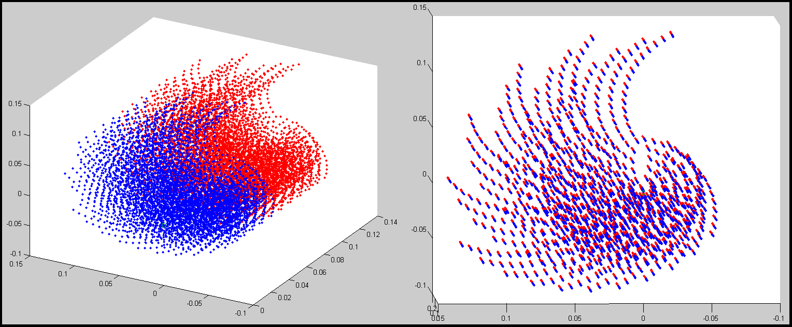

Figure – Prototype 2 MATLAB range of motion simulation

Table 3 summarizes the results for both the experimental and Matlab simulated results.

Table – Summary of critical function prototype analysis

|  |  |  |
| --- | --- | --- |
| **Test** | **Prototype 1** | **Prototype 2** |
| Physical test envelope in x [cm] | 8 | 8 |
| Physical test envelope in y [cm] | 6 | 15 |
| MATLAB max x envelope [cm] | 10 | 10 |
| MATLAB max y envelope [cm] | 7 | 18 |
| MATLAB usable z envelope [cm] | 2 | 7 |

# 6.0 Future Steps and Updated Timeline

A better understanding of the geometry and the installation of uni-compartmental knee implants is required in order to determine if the device's workable area is sufficient to insert both types of implants with one setup, or if the length of Link 3 should be adjustable to allow setup for individual implants. To finalize the design of this concept, development of concepts for other functions of the device that interact/are affected by the 3D motion function need to be further examined; developing these concepts will aid in finalization of the specifics of the critical functions.

A new timeline has been developed to better reflect the current status and goals of the project for the next month, as well as a rough timeline estimate for tasks due in the future. This updated timeline can be found in Appendix C.

# 7.0 Conclusion

The limited range of motion of prototype 1 appears to render it an unfeasible option, while the range of prototype 2 is promising; thus, this will be the concept that will continue to be developed.

With this, the work plan has been updated to allow for research into the use and shape of inter-compartmental knee implants, as well as the further development of concepts for other functions prior to finalization of the details of this concept.

# Appendix A - Supplementary Simulations

Appendix C includes MATLAB analysis of two additional mechanisms. After the analysis of Prototype 1 and 2 it was noted that PT1, as depicted in Figure 2, significantly limits the cutting tool range of motion, and that two hard constraints would be required to successfully implement PT2. Of the mechanisms presented here, Prototype 3 (PT3) is another mechanism that will be considered, and Prototype 4 (PT4) is a redesign version of PT1.

As with PT1 and PT2, these simulations have been developed to provide an approximate range of motion for each prototype and no optimization has been performed on the geometry of any of the prototypes. The lengths and angles used here are based on those chosen for PT1 and PT2 and the generated envelope sizes can be compared without additional analysis.

## Prototype 3:

Prototype 3, shown in Figure 9, implements the hard constraint at joint 2 that will set the minimum length of link 2. This prototype has examined using 2 different setups, PT3a and PT3b.

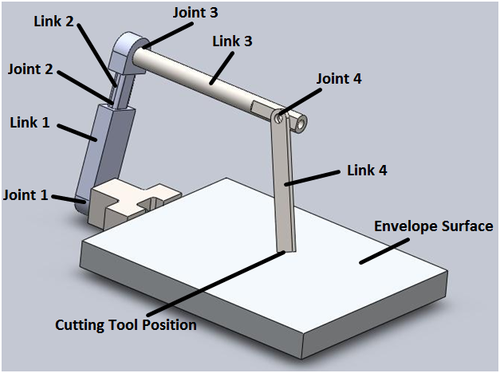

Figure – Model of Prototype 3

**PT3a Mechanism**

In PT3a link 1 is free to rotate about joint 1, while link 3 is held in place with respect to link 2 and joint 3. Link 4 can rotate about joint 4.

**PT3a Results**

The PT3a configuration yielded results similar to PT1. This is expected as PT3a replaces the rotational joint used to provide freedom in the vertical direction at joint 2 with a linear joint, without making any other changes to the mechanism. The approximate envelop for this mechanism and setup has been determined to be 10cm by 10cm by 2 cm – see Table 4 for a comparison of the envelopes of all prototypes.

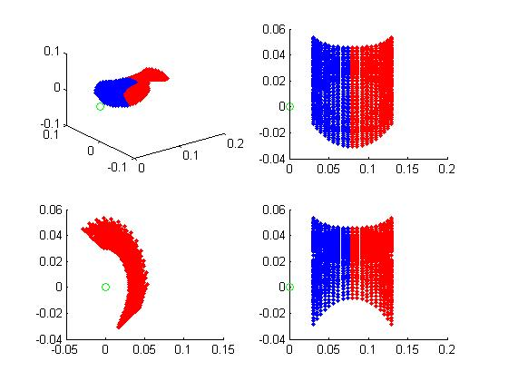

Figure – MATLAB plot of Prototype 3a envelope

**PT3b Mechanism**

For the PT3b mechanism link 1 can be positioned at setup, but is fixed during the surgery. As a result, for the PT3b MATLAB model link 1 is fixed about joint 1 while link 3 was free to rotate about joint 3 with. Link 4 can rotate about joint 4.

**PT3b Results**

Of the mechanisms that only require one hard constraint, the PT3b configuration appears to provide the largest range of motion and has significant vertical freedom.. The approximate envelop for this mechanism and setup has been determined to be 10cm by 8cm by 6cm.

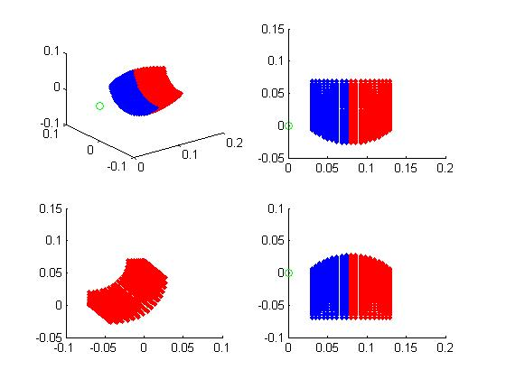

Figure – MATLAB plot of Prototype 3b envelope

## Prototype 4:

The PT4 mechanism repositions joint 4 6 cm higher than the position of joint 4 in PT1. This setup maximizes the possible range of motion of the tool position by maximizing the number of orientations in which link 4 will be approximately perpendicular to link 2 while link 1 is also perpendicular to link 2 – in effect maintaining the angle between links 1 and 2 as far away from any singularities as possible. As shown in Figure 12, link 3 has been completely removed and link 2 is connection to link 4 at joint 4. 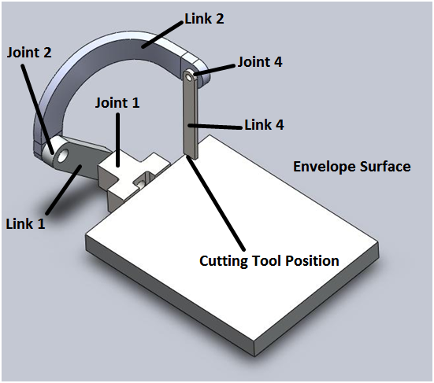

Figure – Model of Prototype 4

**PT4 Mechanism**

In PT4, the hard constraint is implemented at joint 2 and will maintain a minimum angle between link 1 and link 3. In general, link 1 is free to rotate about joint 1, link 2 in free to rotate about joint 2 while away from the hard constraint, and link 4 is free to rotate about joint 4.

**PT4 Results**

The simulated range of motion for this prototype is somewhat surprising. The area this prototype covers in the yz-plane is a very pointed arc, similar to the arc shown in Figure 7 for PT1, and does not provide the same vertical freedom seen in PT3b. The enveloped generated for PT4 is approximately 10cm by 10cm by 2cm. Further simulation could be run in the future to analyse the effect of modifying geometric parameters. The arrangement shown in Figure 12, does not seem to completely implement the desired 90 degree angle between link 1 and an imaginary link 2 (represented by PT1 link 2 in Figure 2), and this is likely to have had an effect on the results.

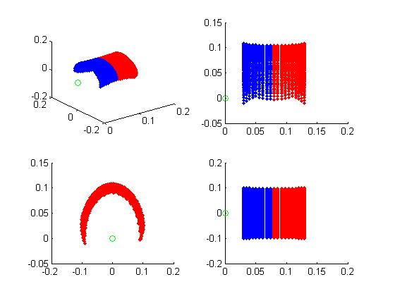

Figure – MATLAB plot of prototype 4 envelope

Table – Summary of Prototype 3 and 4 analysis

|  |  |  |  |  |  |
| --- | --- | --- | --- | --- | --- |
| **Test** | **PT1** | **PT2** | **PT3a** | **PT3b** | **PT4** |
| Physical test envelope in x [cm] | 8 | 8 | - | - | - |
| Physical test envelope in y [cm] | 6 | 15 | - | - | - |
| MATLAB max x envelope [cm] | 10 | 10 | 10 | 10 | 10 |
| MATLAB max y envelope [cm] | 7 | 18 | 10 | 8 | 10 |
| MATLAB usable z envelope [cm] | 2 | 7 | 2 | 6 | 2 |

# Appendix B - Linear hard constraint power screw/worm gear calculations

The following calculation has been preformed to obtain an understanding of the feasibility of implementing a power screw and worm gear system for hard constraint control in a linear displacement joint prototype. The main intended purpose of this calculation was to quantify the minimum motor speed needed to be able to adjust the hard surface constraint in sufficient time.

Main system parameters such as stroke, worm and worm gear pitches, and power screw pitch diameter, have been chosen based on the anticipated size of the linear displacement joint. The mass of the load is assumed to be 10 kg, based on the functional requirement of the device which states that it must resist, at minimum, a pushing force of 10 kg. The speed of the load (the pushing force in this case is assumed to be constant) is assumed to be 0.5 m/s, based on a distance of 0.5 mm (from functional requirements also) to be pushed in 990 microseconds (leaving the remaining time for sensing, transmission, and computation).

**Assumptions**

* Force on constraint = 10kg
* Cutting tool speed = 0.5 m/s
* Required cutting tool movement = 0.5mm
* Available time after position processing = 990 microseconds
* Number of thread on worm gear = 3

**Results**

The torque requirements of the gears and worm involved in the design were calculated, in order to properly spec out these components if needed. In general, the torque/force values are quite low, the majority of available gears will meet the requirement. The required speed of the motor was also found to be approximately 3000 rpm, assuming a triple thread (gain) worm. Although this value is within the realms of physical and mechanical possibility, it is a tough performance to achieve, especially in our high precision and immediate response application.

**Calculations**

Figure 14 and Figure 15 show scans of the calculations made for this analysis.

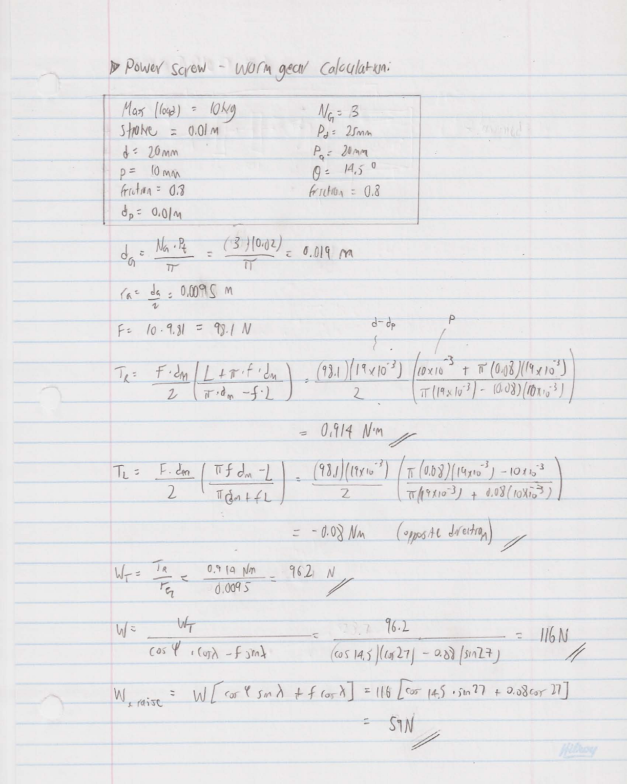

Figure – Power screw/worm gear calculation page 1

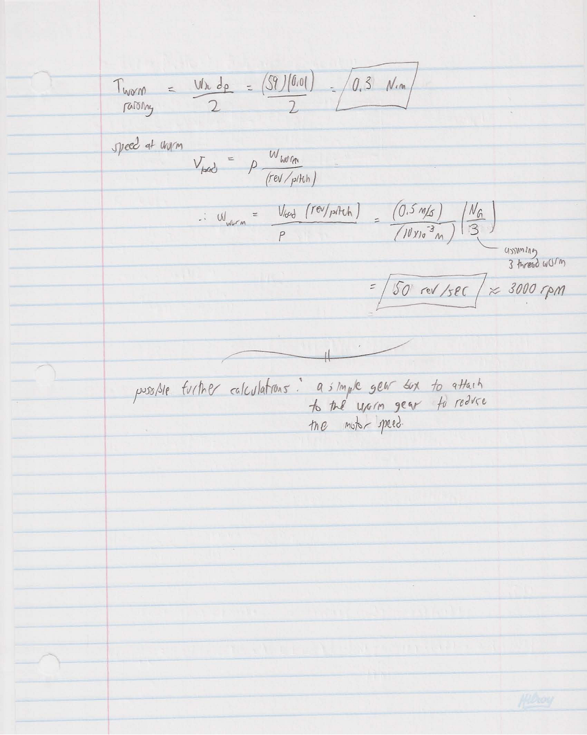

Figure – Power screw/worm gear calculation page 2

# Appendix C - MATLAB Code and Results for PT1

%Geometric Parameters

Length_1 = 6e-2;

Ratio_1to2 = 1.1;

Length_3 = 8e-2;

Theta_3_max = 45;

Length_4 = 7e-2;

Theta_4_max = 45;

Theta_1_max = 60;

Theta_12_min = 30;

Theta_12_max = 135;

Step = pi()/180;

%Calculated Lengths and Conversions to radians

Length_2 = Length_1 * Ratio_1to2;

Theta_3_max = Theta_3_max * pi() / 180;

Theta_4_max = Theta_4_max * pi() / 180;

Theta_1_max = Theta_1_max * pi() / 180;

Theta_1_min = -Theta_1_max ;

Theta_3_min = -Theta_3_max ;

Theta_12_min = Theta_12_min * pi() / 180 ;

Theta_12_max = Theta_12_max * pi() / 180 ;

hold on

subplot(2,1,1), plot3(0,0,0,'go')

subplot(2,1,2), plot3(0,0,0,'go')

%Nested Loops

for Theta_1 = Theta_1_max : -24*Step : Theta_1_min

for Theta_2 = Theta_12_min : 10.5*Step : Theta_12_max

%for Theta_3 = Theta_3_min : 6*Step : Theta_3_max

Theta_3 = -30;

for Theta_4 = 0 : 9*Step : Theta_4_max

%Tool Position

x_position = Length_3 - (Length_4 * sin(Theta_4));

x_position_neg = Length_3 + (Length_4 * sin(Theta_4));

Theta_offset = Theta_2 + Theta_1 - (pi()/2);

Theta_3_offset = Theta_3 + Theta_offset;

y_position = Length_2 * cos(Theta_offset) - Length_1 * sin(Theta_1) + Length_4 * sin(Theta_3_offset);

z_position = Length_1 * cos(Theta_1) + Length_2 * sin(Theta_offset) - Length_4 * cos(Theta_3_offset);

hold all

subplot(2,2,1), plot3(x_position,y_position,z_position,'.'), view(3), hold on

subplot(2,2,1), plot3(x_position_neg,y_position,z_position,'r.'), view(3), hold on

subplot(2,2,2), plot3(x_position,y_position,z_position,'.'), view(0,0), hold on

subplot(2,2,2), plot3(x_position_neg,y_position,z_position,'r.'), view(0,0), hold on

subplot(2,2,3), plot3(x_position,y_position,z_position,'.'), view(90,0), hold on

subplot(2,2,3), plot3(x_position_neg,y_position,z_position,'r.'), view(90,0), hold on

subplot(2,2,4), plot3(x_position,y_position,z_position,'.'), view(0,90), hold on

subplot(2,2,4), plot3(x_position_neg,y_position,z_position,'r.'), view(0,90), hold on

end

%end

end

end

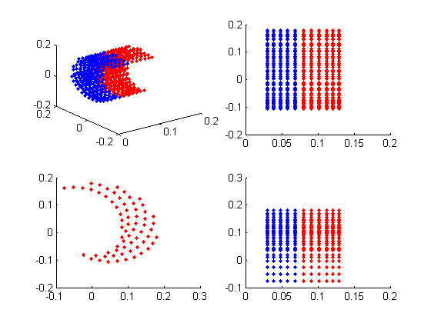

%Geometric Parameters

Theta_1_max = 60 ;

Radius_min = 6e-2 ;

Radius_max = 9e-2 ;

Length_3 = 8e-2 ;

Theta_3 = 30 ;

Length_4 = 7e-2 ;

Theta_4_max = 45 ;

Step = pi() / 180 ;

%Calculated Lengths and Conversions to radians

Theta_1_max = Theta_1_max * pi() / 180 ;

Theta_1_min = -Theta_1_max ;

Theta_3 = Theta_3 * pi() / 180 ;

Theta_4_max = Theta_4_max * pi() / 180 ;

hold on

subplot(2,2,1), plot3(0,0,0,'go'), hold on

subplot(2,2,2), plot3(0,0,0,'go'), hold on

subplot(2,2,3), plot3(0,0,0,'go'), hold on

subplot(2,2,4), plot3(0,0,0,'go'), hold on

%Nested Loops

for Theta_1 = Theta_1_max : -10*Step : Theta_1_min

for Radius = Radius_min : 3e-3 : Radius_max

%for Theta_3 = Theta_3_min : 6*Step : Theta_3_max

for Theta_4 = 0 : 5*Step : Theta_4_max

%Tool Position

x_position = Length_3 - (Length_4 * sin(Theta_4));

x_position_neg = Length_3 + (Length_4 * sin(Theta_4));

y_position = Radius * sin(Theta_1) - Length_4 * cos(Theta_4) * sin(Theta_1 - Theta_3) ;

z_position = Radius * cos(Theta_1) - Length_4 * cos(Theta_4) * cos(Theta_1 - Theta_3) ;

hold all

subplot(2,2,1), plot3(x_position,y_position,z_position,'.'), view(3), hold on

subplot(2,2,1), plot3(x_position_neg,y_position,z_position,'r.'), view(3), hold on

subplot(2,2,2), plot3(x_position,y_position,z_position,'.'), view(0,0), hold on

subplot(2,2,2), plot3(x_position_neg,y_position,z_position,'r.'), view(0,0), hold on

subplot(2,2,3), plot3(x_position,y_position,z_position,'.'), view(90,0), hold on

subplot(2,2,3), plot3(x_position_neg,y_position,z_position,'r.'), view(90,0), hold on

subplot(2,2,4), plot3(x_position,y_position,z_position,'.'), view(0,90), hold on

subplot(2,2,4), plot3(x_position_neg,y_position,z_position,'r.'), view(0,90), hold on

end

%end

end

end



%Geometric Parameters

Length_1 = 6e-2;

Ratio_1to2 = 1.1;

Length_3 = 8e-2;

Theta_3_max = 45;

Length_4 = 7e-2;

Theta_4_max = 45;

Theta_1_max = 60;

Theta_12_min = 30;

Theta_12_max = 135;

Step = pi()/180;

%Calculated Lengths and Conversions to radians

Length_2 = Length_1 * Ratio_1to2;

Theta_3_max = Theta_3_max * pi() / 180;

Theta_4_max = Theta_4_max * pi() / 180;

Theta_1_max = Theta_1_max * pi() / 180;

Theta_1_min = -Theta_1_max ;

Theta_3_min = -Theta_3_max ;

Theta_12_min = Theta_12_min * pi() / 180 ;

Theta_12_max = Theta_12_max * pi() / 180 ;

hold on

subplot(2,1,1), plot3(0,0,0,'go')

subplot(2,1,2), plot3(0,0,0,'go')

%Nested Loops

for Theta_1 = Theta_1_max : -24*Step : Theta_1_min

for Theta_2 = Theta_12_min : 10.5*Step : Theta_12_max

for Theta_3 = Theta_3_min : 6*Step : Theta_3_max

%Theta_3 = -30;

for Theta_4 = 0 : 9*Step : Theta_4_max

%Tool Position

x_position = Length_3 - (Length_4 * sin(Theta_4));

x_position_neg = Length_3 + (Length_4 * sin(Theta_4));

Theta_offset = Theta_2 + Theta_1 - (pi()/2);

Theta_3_offset = Theta_3 + Theta_offset;

y_position = Length_2 * cos(Theta_offset) - Length_1 * sin(Theta_1) + Length_4 * sin(Theta_3_offset);

z_position = Length_1 * cos(Theta_1) + Length_2 * sin(Theta_offset) - Length_4 * cos(Theta_3_offset);

hold all

subplot(2,2,1), plot3(x_position,y_position,z_position,'.'), view(3), hold on

subplot(2,2,1), plot3(x_position_neg,y_position,z_position,'r.'), view(3), hold on

subplot(2,2,2), plot3(x_position,y_position,z_position,'.'), view(0,0), hold on

subplot(2,2,2), plot3(x_position_neg,y_position,z_position,'r.'), view(0,0), hold on

subplot(2,2,3), plot3(x_position,y_position,z_position,'.'), view(90,0), hold on

subplot(2,2,3), plot3(x_position_neg,y_position,z_position,'r.'), view(90,0), hold on

subplot(2,2,4), plot3(x_position,y_position,z_position,'.'), view(0,90), hold on

subplot(2,2,4), plot3(x_position_neg,y_position,z_position,'r.'), view(0,90), hold on

end

end

end

end

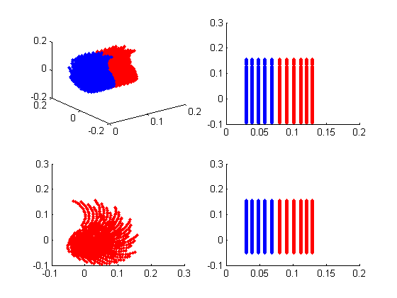

# Appendix E - MATLAB Code and Results for PT3a

%Geometric Parameters

Theta_1_max = 60 ;

Radius_min = 6e-2 ;

Radius_max = 9e-2 ;

Length_3 = 8e-2 ;

Theta_3 = 30 ;

Length_4 = 7e-2 ;

Theta_4_max = 45 ;

Step = pi() / 180 ;

%Calculated Lengths and Conversions to radians

Theta_1_max = Theta_1_max * pi() / 180 ;

Theta_1_min = -Theta_1_max ;

Theta_3 = Theta_3 * pi() / 180 ;

Theta_4_max = Theta_4_max * pi() / 180 ;

hold on

subplot(2,2,1), plot3(0,0,0,'go'), hold on

subplot(2,2,2), plot3(0,0,0,'go'), hold on

subplot(2,2,3), plot3(0,0,0,'go'), hold on

subplot(2,2,4), plot3(0,0,0,'go'), hold on

%Nested Loops

for Theta_1 = Theta_1_max : -10*Step : Theta_1_min

for Radius = Radius_min : 3e-3 : Radius_max

%for Theta_3 = Theta_3_min : 6*Step : Theta_3_max

for Theta_4 = 0 : 5*Step : Theta_4_max

%Tool Position

x_position = Length_3 - (Length_4 * sin(Theta_4));

x_position_neg = Length_3 + (Length_4 * sin(Theta_4));

y_position = Radius * sin(Theta_1) - Length_4 * cos(Theta_4) * sin(Theta_1 - Theta_3) ;

z_position = Radius * cos(Theta_1) - Length_4 * cos(Theta_4) * cos(Theta_1 - Theta_3) ;

hold all

subplot(2,2,1), plot3(x_position,y_position,z_position,'.'), view(3), hold on

subplot(2,2,1), plot3(x_position_neg,y_position,z_position,'r.'), view(3), hold on

subplot(2,2,2), plot3(x_position,y_position,z_position,'.'), view(0,0), hold on

subplot(2,2,2), plot3(x_position_neg,y_position,z_position,'r.'), view(0,0), hold on

subplot(2,2,3), plot3(x_position,y_position,z_position,'.'), view(90,0), hold on

subplot(2,2,3), plot3(x_position_neg,y_position,z_position,'r.'), view(90,0), hold on

subplot(2,2,4), plot3(x_position,y_position,z_position,'.'), view(0,90), hold on

subplot(2,2,4), plot3(x_position_neg,y_position,z_position,'r.'), view(0,90), hold on

end

%end

end

end



# Appendix F - MATLAB Code and Results for PT13b

%Geometric Parameters

Theta_3_max = 45 ;

Radius_min = 6e-2 ;

Radius_max = 10e-2 ;

Length_3 = 8e-2 ;

Theta_1 = -45 ;

Length_4 = 7e-2 ;

Theta_4_max = 45 ;

Step = pi() / 180 ;

%Calculated Lengths and Conversions to radians

Theta_3_max = Theta_3_max * pi() / 180 ;

Theta_3_min = -Theta_3_max ;

Theta_1 = Theta_1 * pi() / 180 ;

Theta_4_max = Theta_4_max * pi() / 180 ;

hold on

subplot(2,2,1), plot3(0,0,0,'go'), hold on

subplot(2,2,2), plot3(0,0,0,'go'), hold on

subplot(2,2,3), plot3(0,0,0,'go'), hold on

subplot(2,2,4), plot3(0,0,0,'go'), hold on

%Nested Loops

%for Theta_3 = Theta_3_max : -10*Step : Theta_3_min

for Radius = Radius_min : 3e-3 : Radius_max

for Theta_3 = Theta_3_min : 6*Step : Theta_3_max

for Theta_4 = 0 : 5*Step : Theta_4_max

%Tool Position

x_position = Length_3 - (Length_4 * sin(Theta_4));

x_position_neg = Length_3 + (Length_4 * sin(Theta_4));

y_position = Radius * sin(Theta_1) - Length_4 * cos(Theta_4) * sin(Theta_1 - Theta_3) ;

z_position = Radius * cos(Theta_1) - Length_4 * cos(Theta_4) * cos(Theta_1 - Theta_3) ;

hold all

subplot(2,2,1), plot3(x_position,y_position,z_position,'.'), view(3), hold on

subplot(2,2,1), plot3(x_position_neg,y_position,z_position,'r.'), view(3), hold on

subplot(2,2,2), plot3(x_position,y_position,z_position,'.'), view(0,0), hold on

subplot(2,2,2), plot3(x_position_neg,y_position,z_position,'r.'), view(0,0), hold on

subplot(2,2,3), plot3(x_position,y_position,z_position,'.'), view(90,0), hold on

subplot(2,2,3), plot3(x_position_neg,y_position,z_position,'r.'), view(90,0), hold on

subplot(2,2,4), plot3(x_position,y_position,z_position,'.'), view(0,90), hold on

subplot(2,2,4), plot3(x_position_neg,y_position,z_position,'r.'), view(0,90), hold on

end

end

end

%end



# Appendix G - MATLAB Code and Results for PT4

%Geometric Parameters

Length_1 = 5e-2;

Ratio_1to2 = 1.1;

Length_3 = 8e-2;

Theta_3_max = 45;

Length_4 = 7e-2;

Theta_4_max = 45;

Theta_1_max = 60;

Theta_12_min = 30;

Theta_12_max = 135;

Step = pi()/180;

%Calculated Lengths and Conversions to radians

Length_2 = Length_1 * Ratio_1to2;

Theta_3_max = Theta_3_max * pi() / 180;

Theta_4_max = Theta_4_max * pi() / 180;

Theta_1_max = Theta_1_max * pi() / 180;

Theta_1_min = -Theta_1_max ;

Theta_3_min = -Theta_3_max ;

Theta_12_min = Theta_12_min * pi() / 180 ;

Theta_12_max = Theta_12_max * pi() / 180 ;

hold on

subplot(2,2,1), plot3(0,0,0,'go'), hold on

subplot(2,2,2), plot3(0,0,0,'go'), hold on

subplot(2,2,3), plot3(0,0,0,'go'), hold on

subplot(2,2,4), plot3(0,0,0,'go'), hold on

%Nested Loops

for Theta_1 = Theta_1_max : -10*Step : Theta_1_min

for Theta_12 = Theta_12_min : 7*Step : Theta_12_max

%for Theta_3 = Theta_3_min : 6*Step : Theta_3_max

%Theta_3 = 0;

for Theta_4 = 0 : 5*Step : Theta_4_max

%Tool Position

x_position = Length_3 - (Length_4 * sin(Theta_4));

x_position_neg = Length_3 + (Length_4 * sin(Theta_4));

delta_z = Length_4 * (1 - cos(Theta_4));

Length_2_star = (Length_2 ^2 + delta_z ^2) ^.5;

Theta_star = tan(delta_z / Length_2) ;

Theta_12_star = Theta_12 + Theta_star ;

y_position = Length_2_star * cos(Theta_1 + Theta_12_star) - Length_1 * sin(Theta_1) ;

z_position = Length_2_star * sin(Theta_1 + Theta_12_star) + Length_1 * cos(Theta_1) ;

hold all

subplot(2,2,1), plot3(x_position,y_position,z_position,'.'), view(3), hold on

subplot(2,2,1), plot3(x_position_neg,y_position,z_position,'r.'), view(3), hold on

subplot(2,2,2), plot3(x_position,y_position,z_position,'.'), view(0,0), hold on

subplot(2,2,2), plot3(x_position_neg,y_position,z_position,'r.'), view(0,0), hold on

subplot(2,2,3), plot3(x_position,y_position,z_position,'.'), view(90,0), hold on

subplot(2,2,3), plot3(x_position_neg,y_position,z_position,'r.'), view(90,0), hold on

subplot(2,2,4), plot3(x_position,y_position,z_position,'.'), view(0,90), hold on

subplot(2,2,4), plot3(x_position_neg,y_position,z_position,'r.'), view(0,90), hold on

end

%end

end

end

